**ABC of WCF**

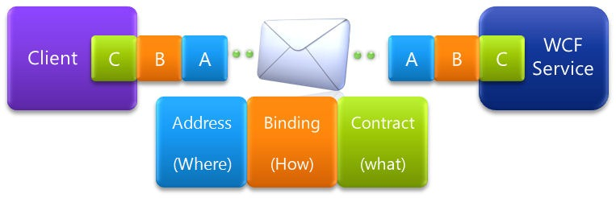

**Rameshkartik.RS**

**Table of Contents**

Introduction 3

END point 3

Address 4

Binding 5

Contract 7

Summary 7

**WHAT’s IN THIS ARTicle?**

* Introduction
* What are needed to create ENDPOINT?
* What is an Address?
* Brief on Binding
* Summary

# Introduction

In earlier day developer needs to do a lot of ground work to shape the communication architecture between the components, But now Microsoft provides WCF – a flexible programming framework which abstracts a lot of complexity in creating the services. So the communication foundation is already laid/available for the developers.It makes the developers to concentrate only on the problems. One of the finest benefits I have seen in WCF is same business logic could implement in different protocols and transport options. So that your service can be exposed to any type of client.

# END point

With a simple and elegant example, I just try to explain you about the End Point in WCF, Imagine that you are trying to send a birthday gift to your beloved ones living near your city. What exactly the information you really require to send away? The first and the foremost is the Address,where the gift needs to be delivered. And the second one is How this gift would be transmitted? What are all the transport options available to reach that address? By train or bus? And the last one you must know what is the content you are transmitting? What type of goods it is?. Yes in WCF to define an Endpoint ABC is required to establish the communication. A stands for Address, B stands for Binding and the C stands for Contract. Please try to match the ABC with the example I mentioned above, then you come to know what I mean it? Anyway, we will discuss this topic in detail here. Once you define the ABC,everything will be taken care by WCF.

# Address

A – Address

Address – Where exactly your service is hosted? I.e. Location of service. An address could be IP Address, Server name, URL etc...

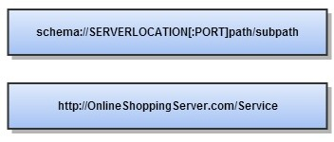

Above one is the format of the address, whereas the first part is the transport schema, In our case http is the transport schema, whereas the second part is the server location, In our case OnlineShoppingServer.com is the server location. And the next part is the PORT number where the server is listening for incoming requests. And the final part is the relative location of the resource on the server.

|  |  |
| --- | --- |
| **Transport Protocol** | **Example Address** |
| HTTP | <http://localhost:8001/Service> |
| HTTP (Secure) | <https://localhost:8001/Service> |
| TCP | net.tcp://localhost:8001/Service |
| PEER network | net.p2p://localhost/ |
| IPC (Inter-process Communication over named pipes) | net.pipe://localhost/Service |
| MSMQ (Microsoft Message Queue) | net.msmq://localhost |

|  |  |
| --- | --- |
| **HTTP** | It’s a Protocol for Communication over web |
| **TCP** | High Performance communication in WCF-WCF. Good for intranet scenarios |
| **Named PIPE** | Fast and reliable communication between client and server running on same machine |
| **MSMQ** | Used when client en queues a message that a service can then consume later |

WCF allows you to communicate with clients over any protocols mentioned above. Based upon your project requirements you can decide your transport protocol.

# Binding

B – Binding

Binding – It is about how the messages are handled in the service side and the client side. Binding is a group of elements which corresponds to transport and protocol channels located in the channel stack. Channel stack is the sequence of channels that each passes through to the run time execution. So what is transport, protocol channels? Let’s discuss here with a WCF Run time execution diagram.

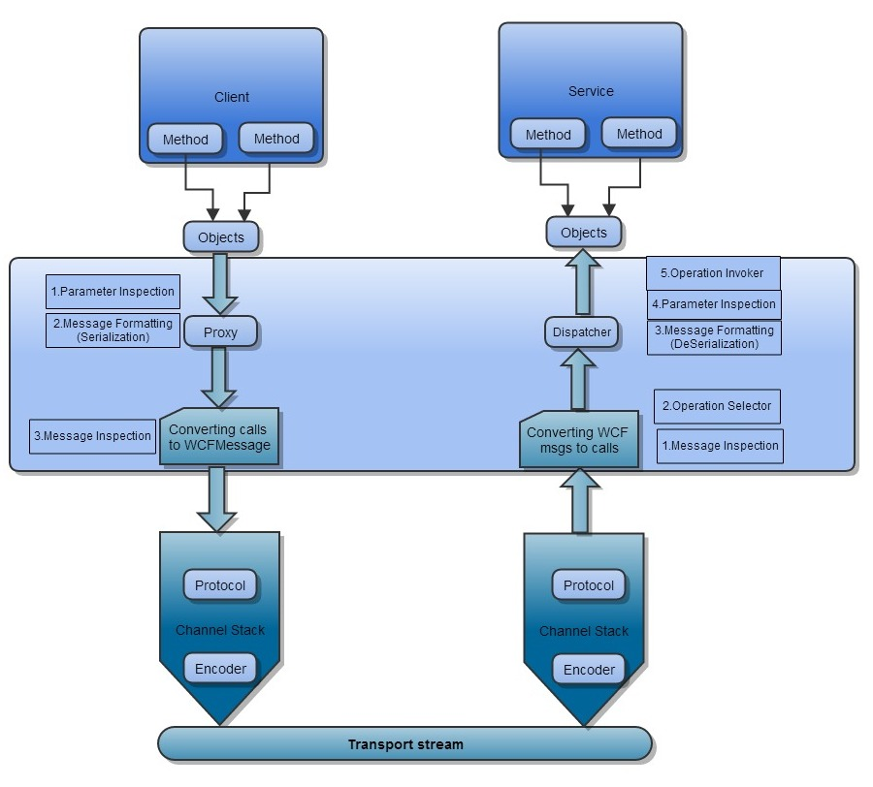

Transport Channel – As I mentioned in the diagram, transport channel lies at the bottom of the stack, responsible for transporting messages from client to the server using the transport protocols like HTTP, HTTPS, TCP, IPC (Named Pipes), MSMQ. The main responsibility is message encoding and transport.

Protocol Channel – It lies on the top of the transport channel. Protocol channel contains protocols like Security Protocol, Reliable Messaging, and Transaction Protocol. Responsible for providing security features like authorization, authentication, protection and confidentiality.

|  |
| --- |
| **Protocol Channel** |
| Security Protocol |
| Reliable Messaging |
| Transaction Protocol |

# Contract

# Contract – Agreement

Contract is an agreement between the client and the server about the structure and content of message being exchanged. Data Contract is about the structure of the message, where as the message contract is about the content of the message being exchanged. If you need more detail on the Data Contracts and the message contracts, please refer my previous articles

# Summary

To reach an endpoint, Where (Address), How (Binding) and What (Contract) are really important to establish communication.